|  |  |  |
| --- | --- | --- |
|  |  | **School Newsletter 12th June 2023** |
| **Ltyentye Apurte Catholic School**  Church Street, Santa Teresa, PMB 221, Via Alice Springs, NT, 0872.  Tel: (08) 8956 0937 email: justin.colley@nt.catholic.edu.au |

Dear Families,

**We have made it to the end of Semester One.** It has been an extraordinary semester with many challenges and successes. We started Term 1 with a teacher in front of every class (not easy during a national teacher shortage crisis) but no leadership team – other than Cate and I. Fortunately, we were able to employ Mr D as the Acting Deputy Principal & Religious Education Leader, and then Leonard as Curriculum Leader. During the semester we also employed Chantal, Kaz and Jason and all three new staff have made a great difference. Other highlights of Semester 1 include: Deadly Heart Trek, the Seniors camp to the Michael Long Learning & Leadership Centre, Physical Education with Spinifex Skateboards, the Arrernte Songs Project, contributing to plans for the community Language & Culture Centre and JR and Kefon becoming dads*!*

As Week 9 begins I have another **new staff** to tell you about. Please make her feel welcome in community.

|  |  |
| --- | --- |
|  | WELCOME, **Carol Muir**. Carol has worked here before and is well known by many of you. In fact, she taught a number of our Arrernte teachers when they were children, including Marcus and Jane. Carol will be working as our Teacher Linguist and will help us on our journey to become a more bilingual school. She will be here for two days a week for the rest of the year and maybe more next year. |

Last week, **RJ (Terrence Conway)** visited our assembly to talk about his participation in the **Finke Desert Race** over the long weekend. RJ is a strong and courageous Arrernte man who made an amazing recovery from a motorbike accident a few years ago. We wished him Godspeed and safety for the race and took these lovely photos of RJ with his bike and many supporters at school…

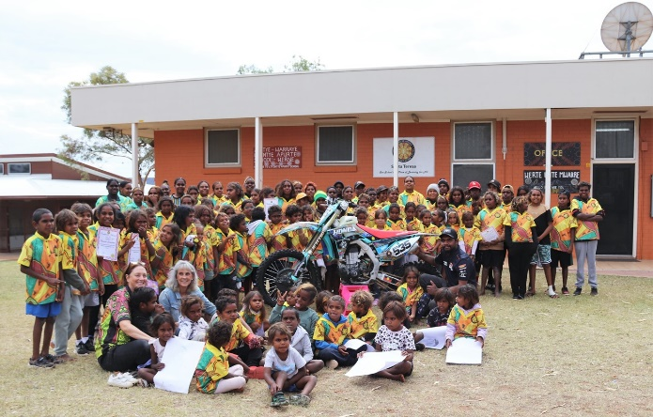

*GODSPEED, RJ !*

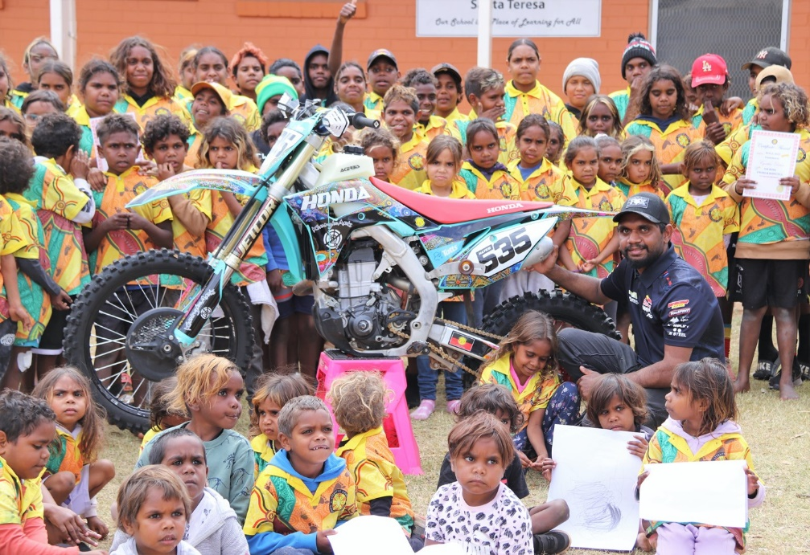

*And*

*SAFETY…*

**OTHER NEWS**

Since the last newsletter, **Secondary 1 and Senior Secondary** students were visited by the **NT Government Parliamentary Education Team**. Students learned how NT Government works and how laws are made. They even got to pass a new law… that school should start at 12 pm (midday) every day! Mr Justin was not impressed!

|  |  |  |
| --- | --- | --- |
|  |  |  |

A lot of good learning has also taken place in the **Senior Ladies** in recent weeks. Students participated in the **Intergenerational Sewing Workshops** with Maree Stone in Weeks 6 and 7. Senior Ladies have completed the last activities for their **Duke of Edinburgh Award**. As part of their volunteering work they delivered blankets to some Ltyentye Apurte Elders that were donated by the Order of Malta. Students also participated very well in a **Football Gala Day** at Yipirinya School last Wednesday.

|  |  |  |
| --- | --- | --- |
|  |  |  |
|  |  |  |
| Above: Intergenerational Sewing Workshop (2). A high standard of work. | | |
|  |  |  |
| Above: Duke of Edinburgh – Ladies presenting Elders with blankets from the Order of Malta. | | |

**MORE OTHER NEWS:**

Thanks to Catholic Care, **FREE TICKETS to the Alice Springs Show** for students that come to school EVERY DAY in the last two weeks of Term 2. That’s Tuesday 13th to Friday 23rd June 2023. We will also be giving **Meat Packs** to the best attending students in the first three weeks of school after the holiday.

Please send your children to school. Local jobs depend on it.

**FAITH FOCUS (From our REC, Mr D)**

|  |  |
| --- | --- |
|  | The **Feast of Corpus Christi** (on Sunday) celebrated Christ’s gift of the Eucharist and focuses on His presence in the form of bread and wine. It’s important for us to understand the powerful, spiritual nature of the Eucharist. Jesus left it so that we could stay close to Him. In receiving the Body and Blood of Christ, we become what we receive but we’re called to *give* too… He calls us to prayer and to follow his way in being kind, compassionate and giving spirit to those in need. |

**THIS Week and Ahead:**

|  |  |
| --- | --- |
|  | **Wednesday 14th June** from **10 am: Athletics Carnival / Sports Day.** We’ll be on the Oval. Classes have been preparing for this during Term 2. Team Chants. All families welcome to come and watch. |
| Free Customer Report Cliparts, Download Free Clip Art, Free Clip ... | **Wednesday 21st June** from **3 pm: Student Reports.** Teachers have worked very hard writing your children’s reports. We’re handing them over on in the library. Talk to your child’s teacher. See how they’ve been doing. Afternoon tea provided. |
| C:\Users\justin.colley\AppData\Local\Microsoft\Windows\INetCache\Content.MSO\1DA39FC4.tmp | **Thursday 22nd June: End of Semester Awards Assembly.** Attendance + Principal Award winners. Come and see. Start at **11:30 am** in the library. All families welcome. |
| January School Holiday Fun – St Ives Village Shopping Centre | **Friday 23th June:** Last day of school. **LACS will be CLOSED for three (3) weeks**. Students and staff have worked very hard this semester. We need a holiday now. |
| content_1560795234-back-to-school-1200-x-627-Custom - Pleasant ... | **BACK TO SCHOOL:**   * LACS re-opens for **STAFF** on **Monday 17th July**. We will be in training. * LACS re-opens for **STUDENTS** on **Tuesday 18th July**. |

*Kele Mwarre!* May God bless and keep safe all Ltyentye Apurte families over the holidays.



Principal

* **School CLOSED before 7:45 am. BREAKFAST starts at 8 am. SCHOOL starts at 8:30 am and finishes at 3pm.**
* **LACS is committed to the teachings of love and justice from Jesus in the Gospels. We are committed to the**

**safety and wellbeing of all students. We have zero tolerance for child abuse and exploitation.**